**EE 603- Assignment 2  
Digital Signal Processing and it’s applications**

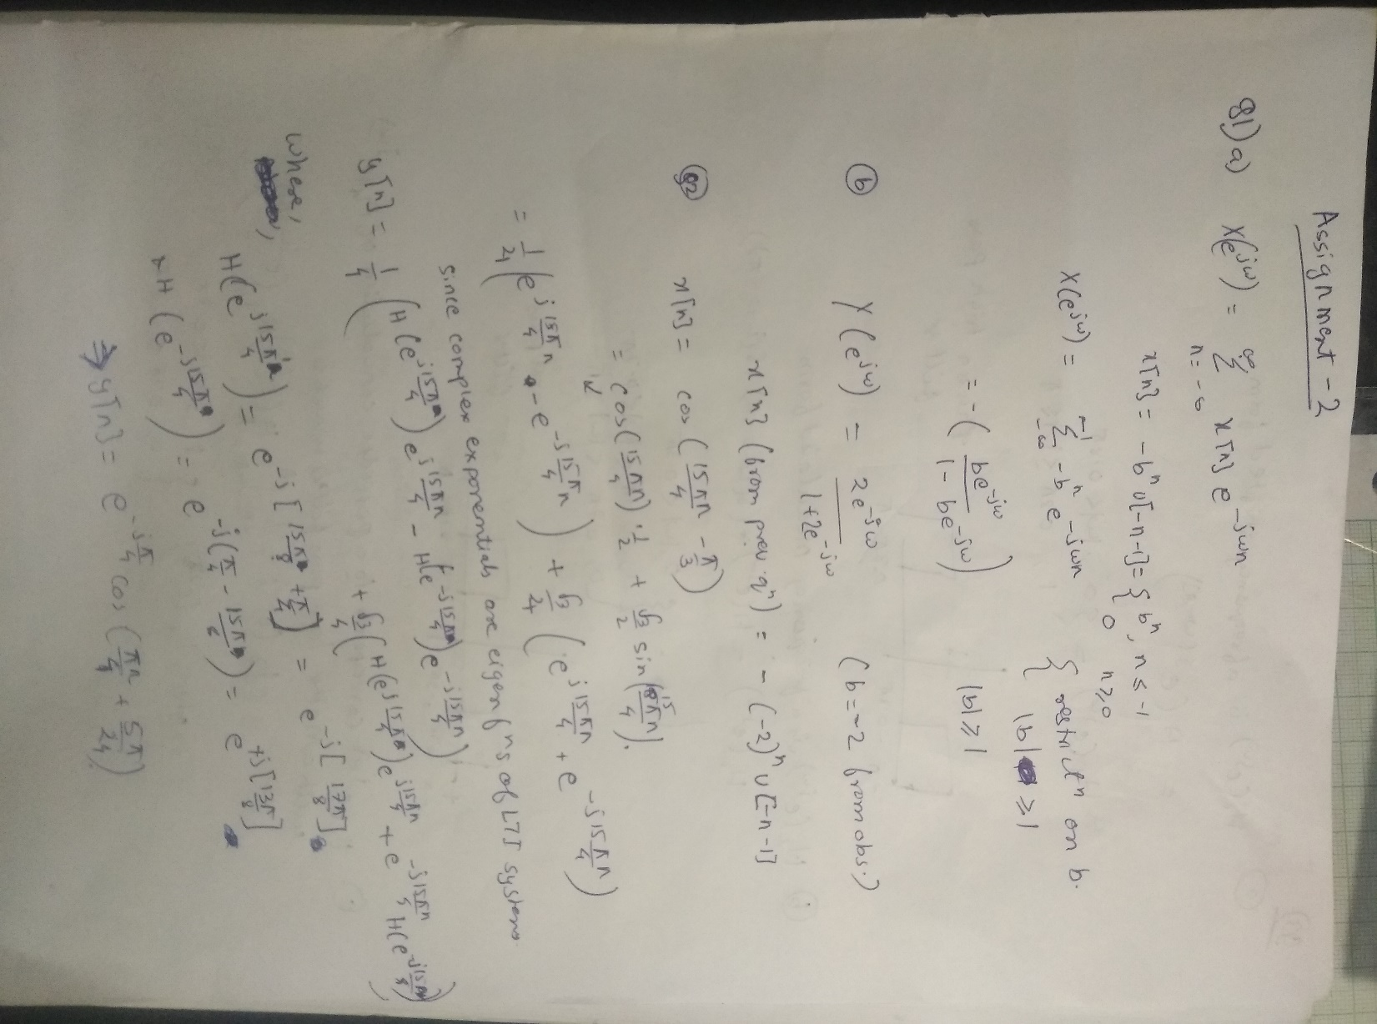

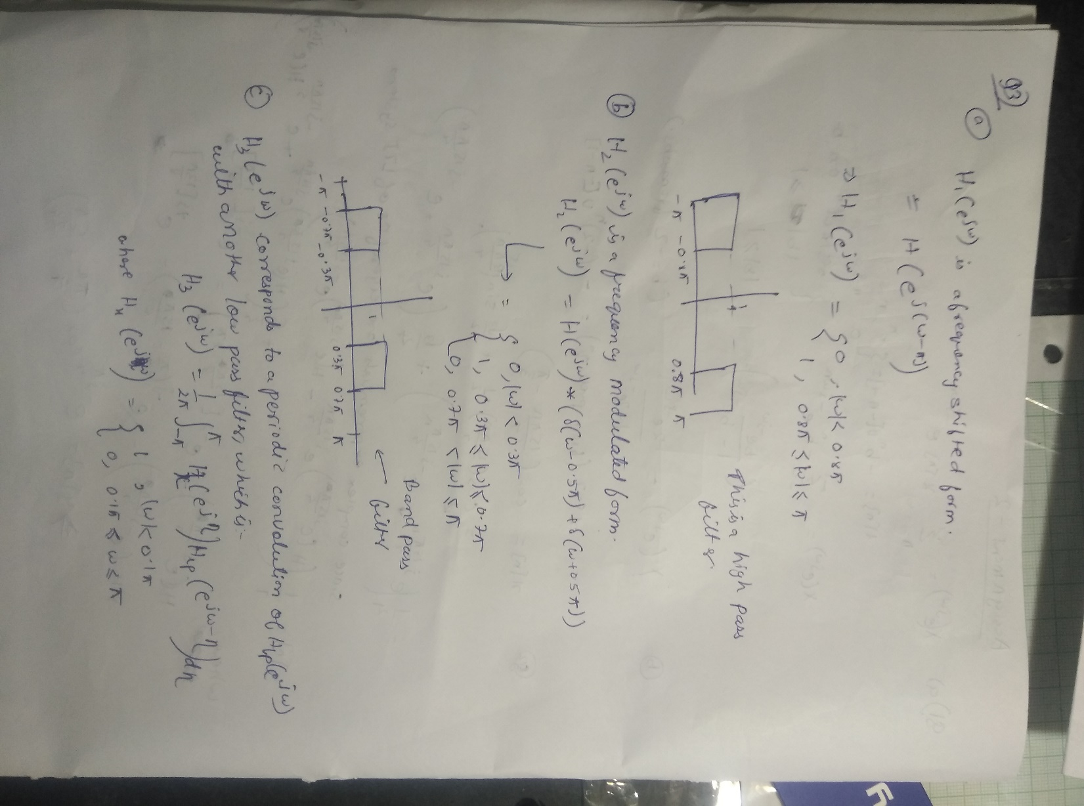

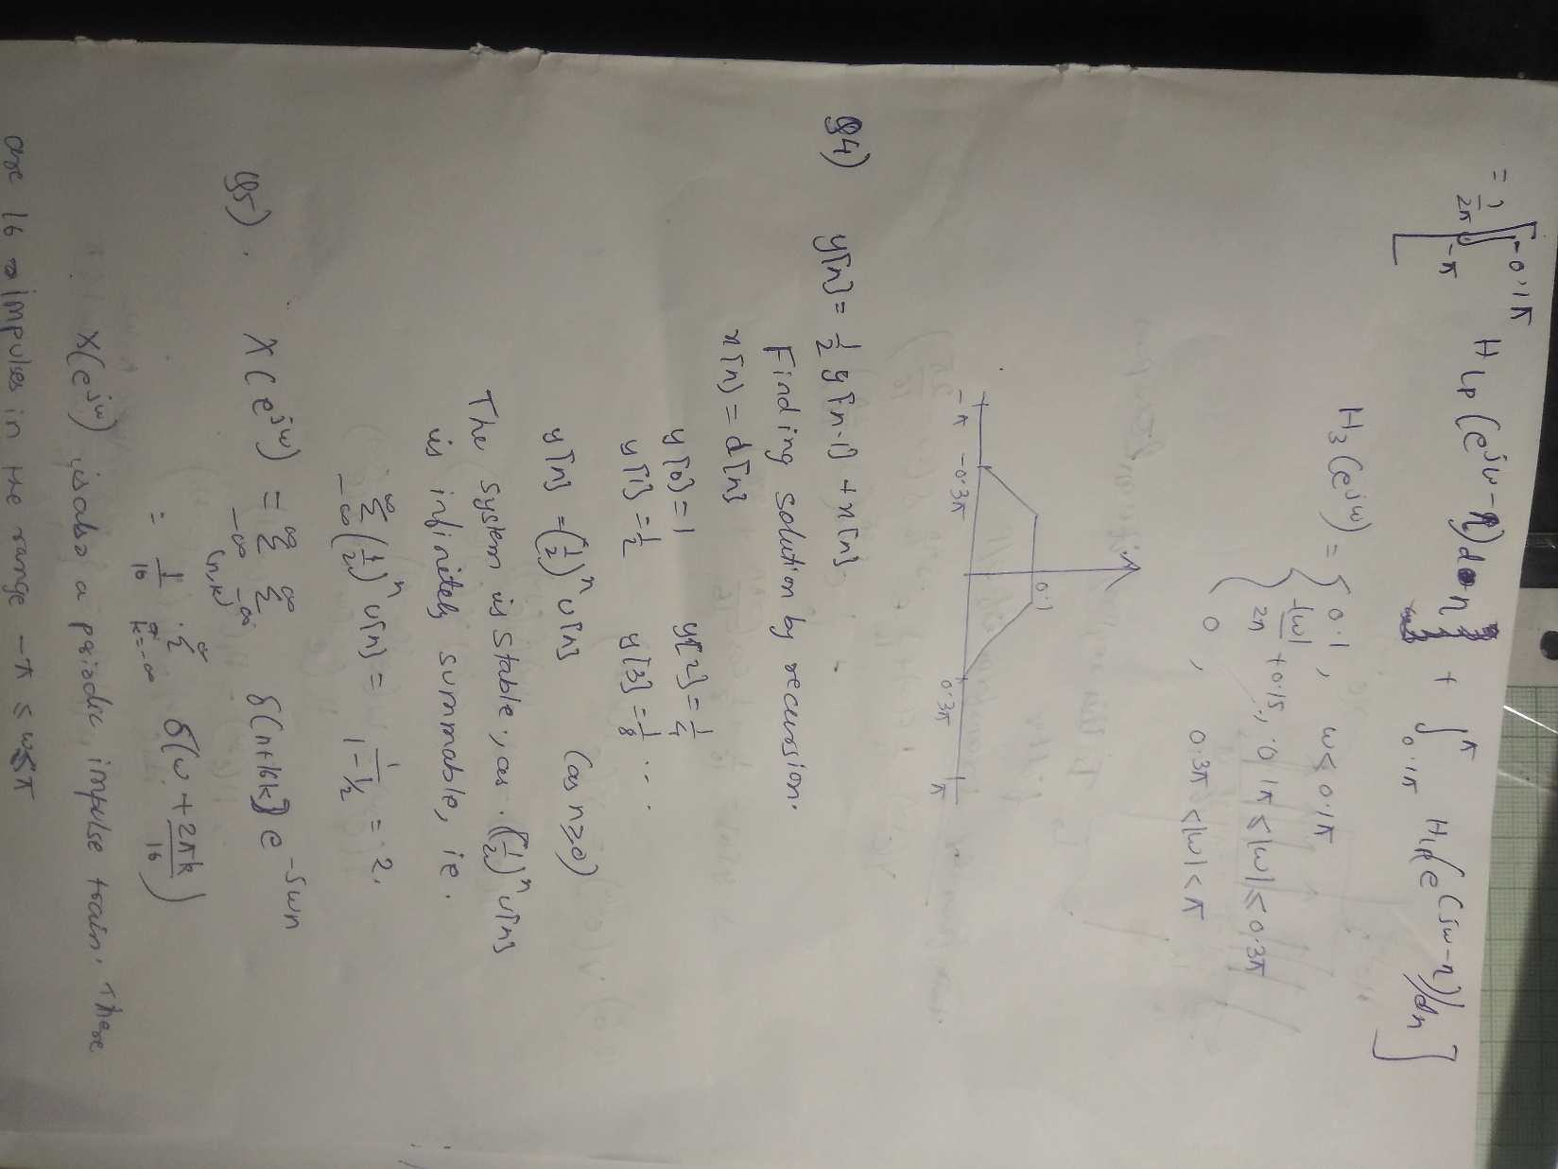

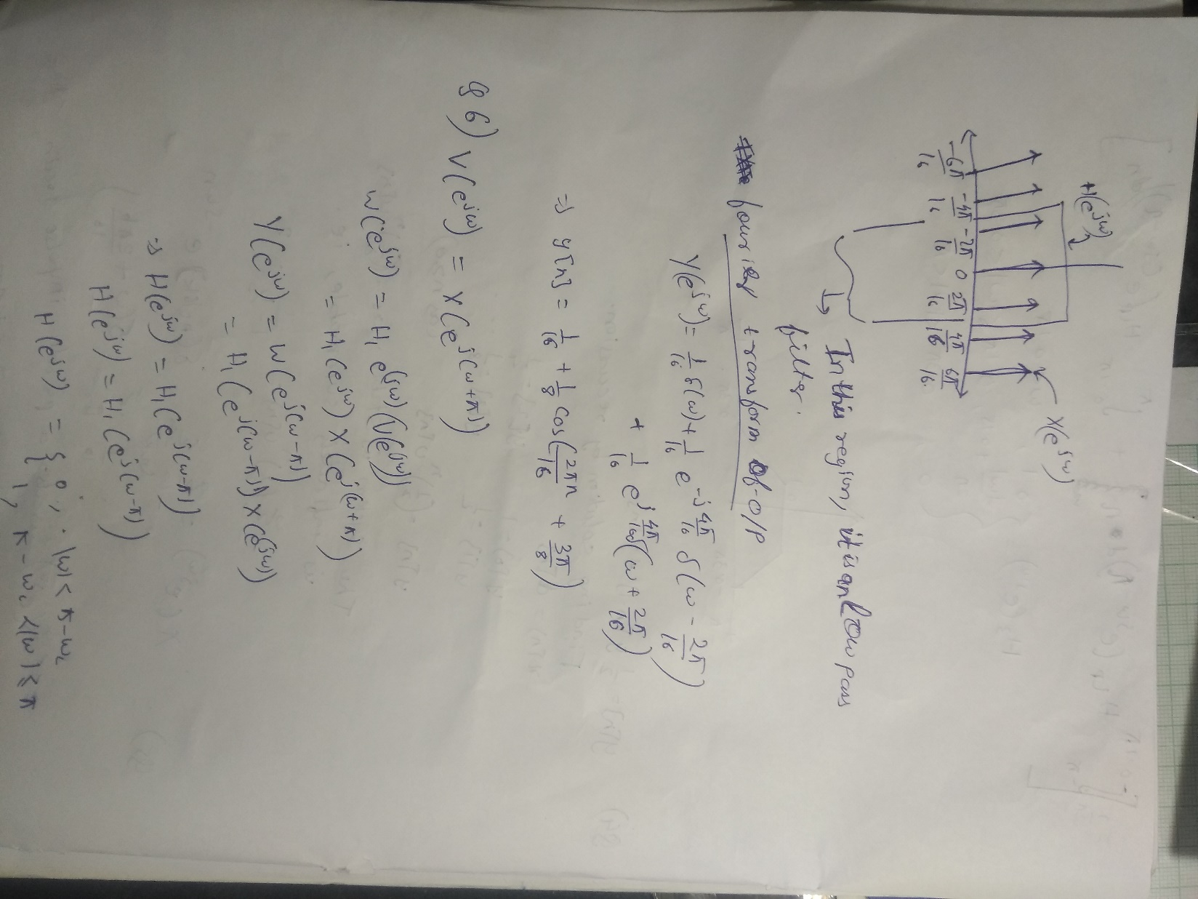

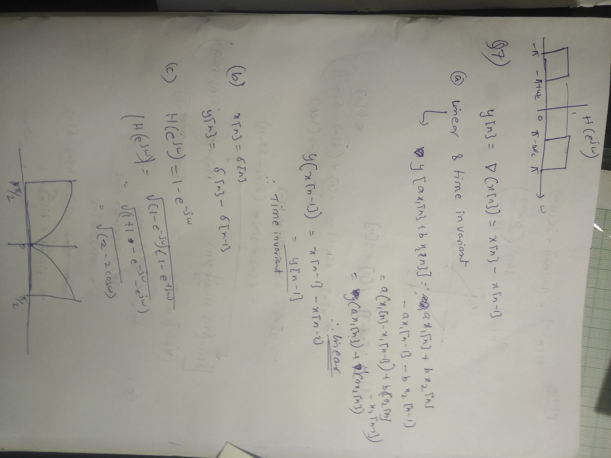

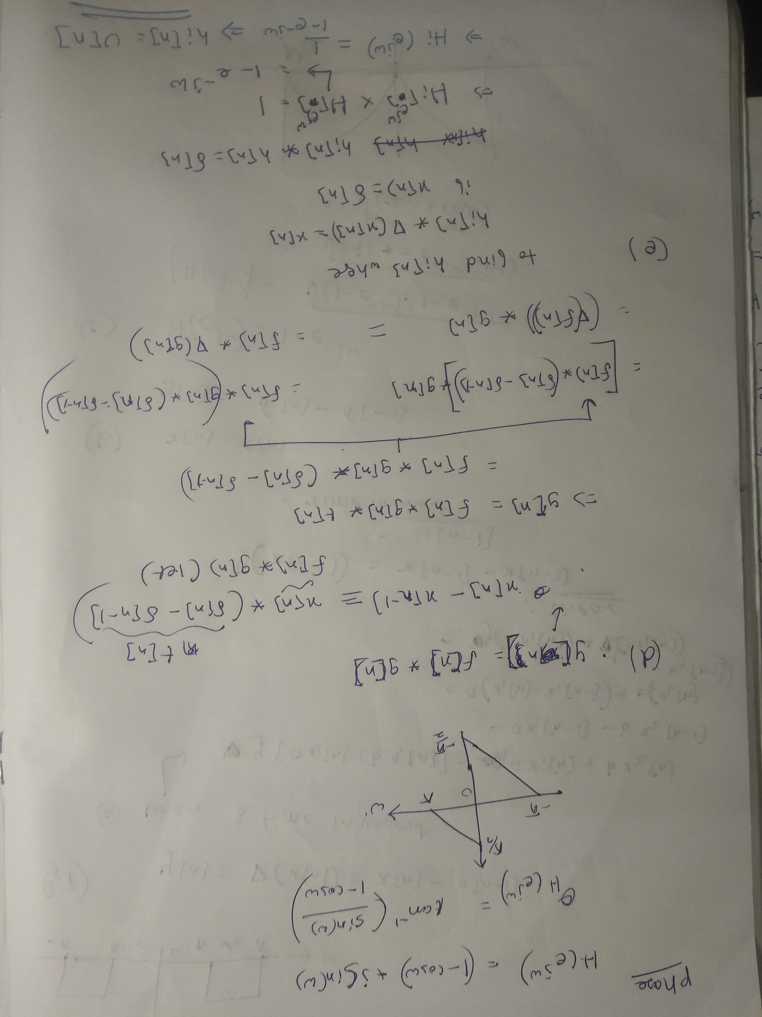

**Question 8**

1. Code:   
   n =-100:100;

Fs= 20;

t=-100:1/Fs:100;

x=cos(2*pi*t)+2*sin(12*pi*t);

plot(t,x);

Plot:

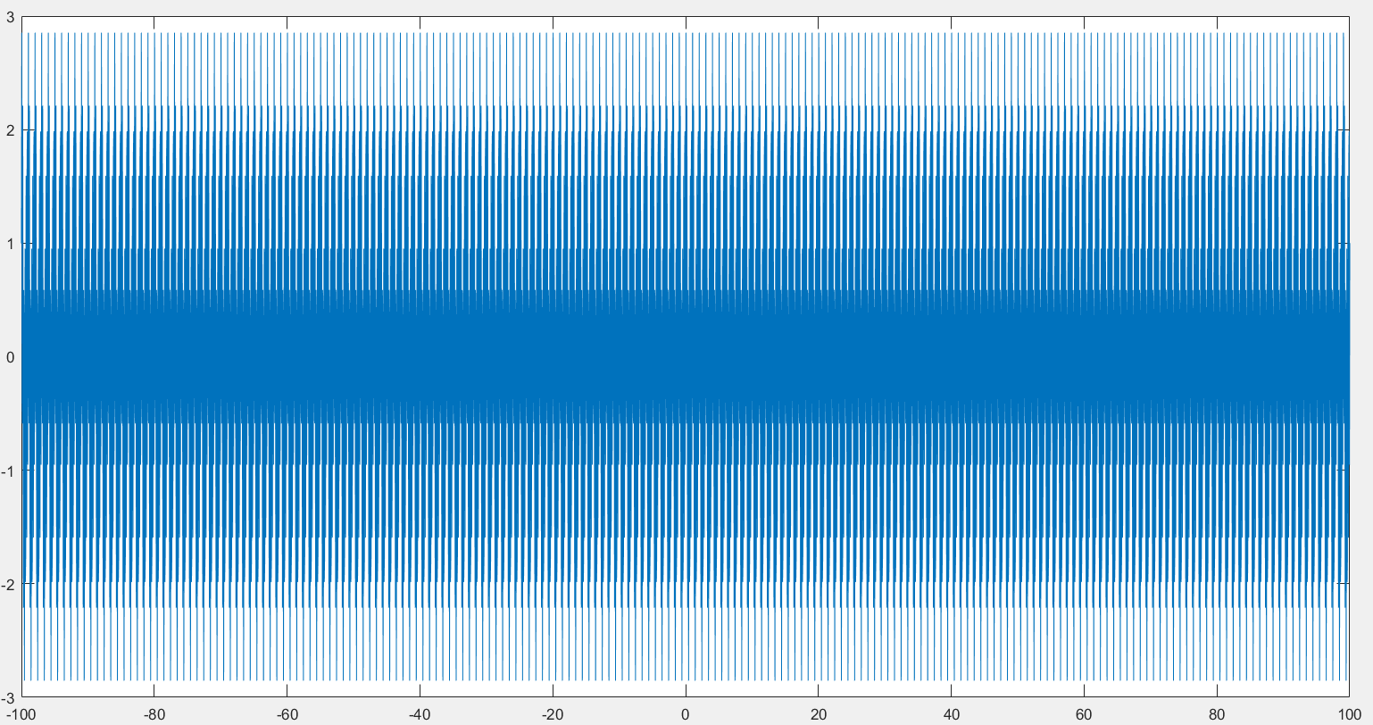

1. Code:   
   n =-100:100;

Fs= 20;

t=-100:1/Fs:100;

x=cos(2*pi*t)+2*sin(12*pi*t);

freqz(x);

Plot:

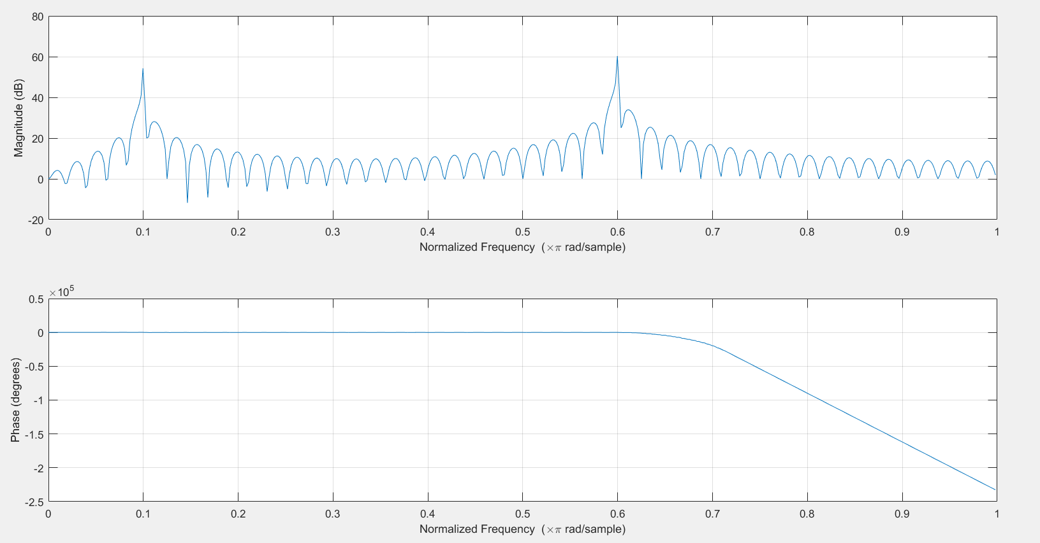

1. Code:   
   Fs= 20;

t=-100:1/Fs:100;

myfilter=sinc(4*t);

freqz(myfilter);

Plot:

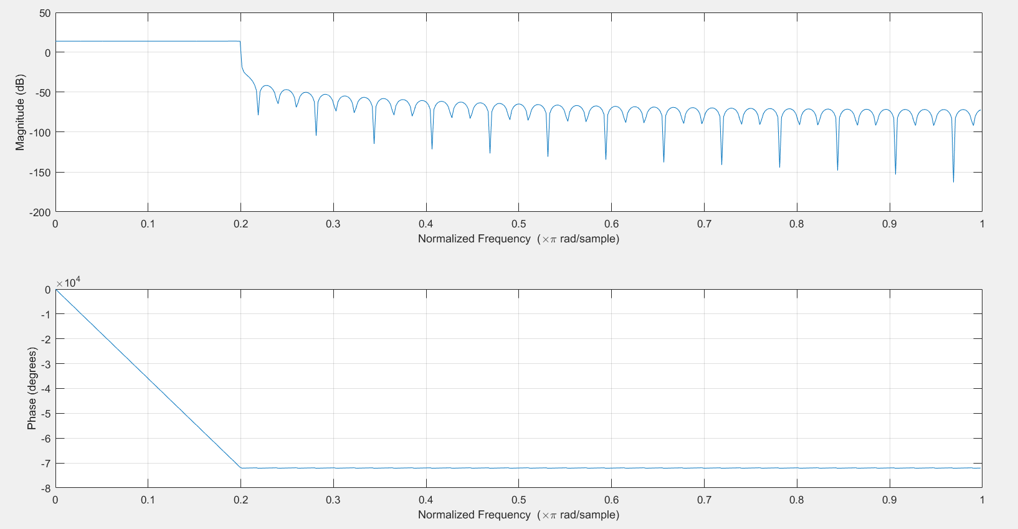

1. Code:   
   Fs= 20;

t=-100:1/Fs:100;

myfilter=sinc(2*t);

myfilter2=myfilter.*cos(12*pi*t);

freqz(myfilter2);  
  
Plot:

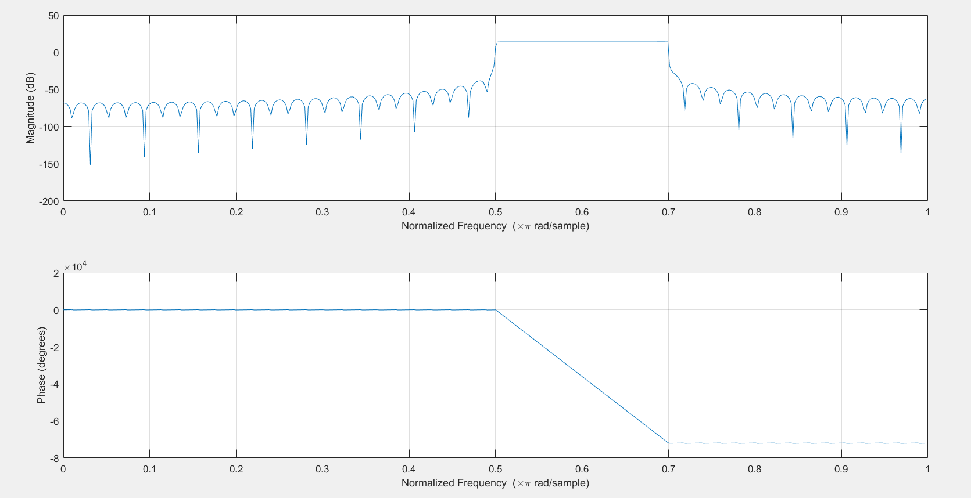

1. Code:   
   Fs= 20;

t=-100:1/Fs:100;

x=cos(2*pi*t)+2*sin(12*pi*t);

myfilter=sinc(2*t);

myfilter2=myfilter.*cos(12*pi*t);

plot(conv(x,myfilter2));  
  
Plot:

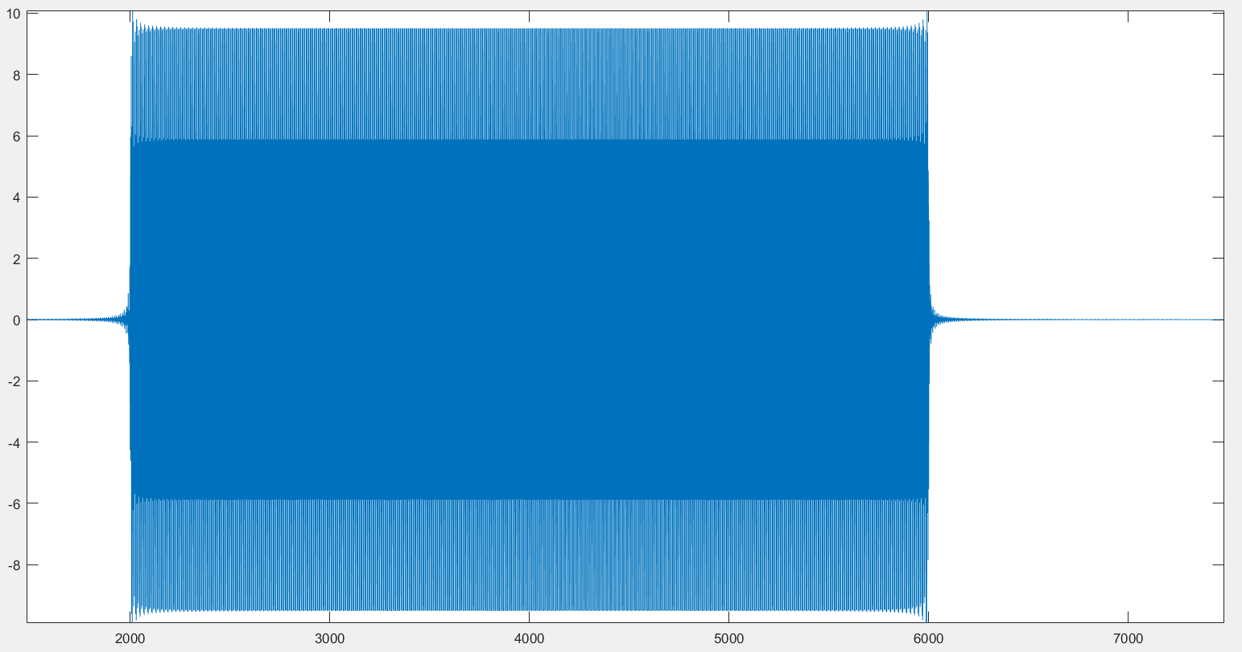

Freqz:

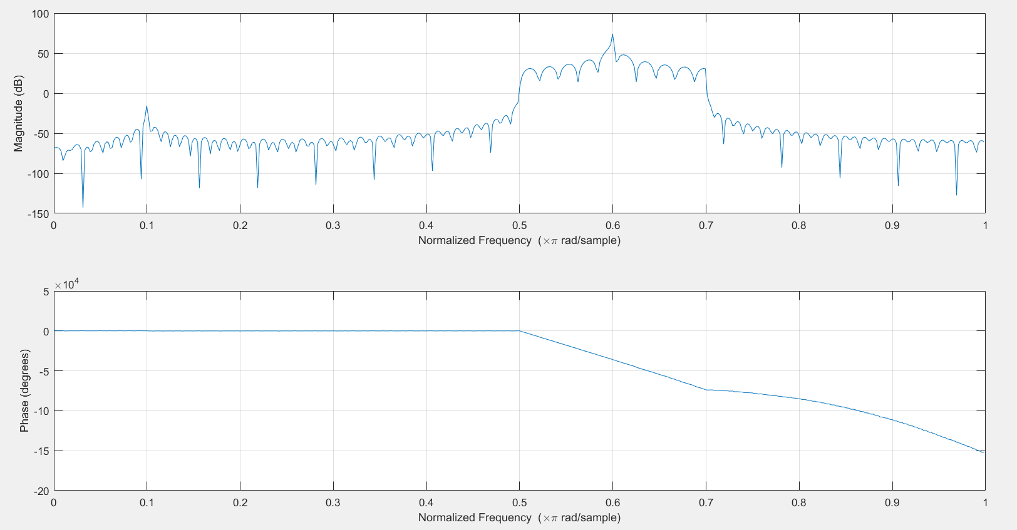

We observe a high varying output between 5 Hz and 7 Hz, and on the plot we see a box like figure. This is because the filter filtered out all frequencies in the input signal x(t), except for the frequencies 5 to 7 Hz. This means that the sine wave is passed(the peak at 0.6) but the cos wave is blocked.